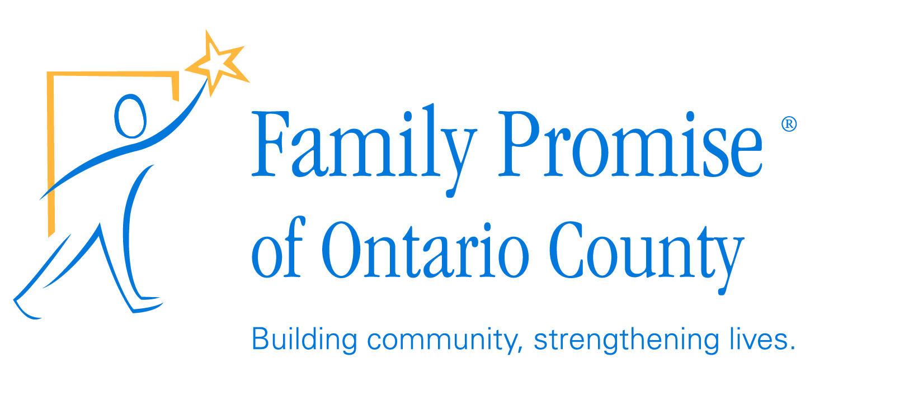

DATE
NAME
ADDRESS
CITY, STATE, ZIP

Dear XXX ,
Family Promise of Ontario County is dedicated to providing a pathway for homeless families in our community to achieve sustainable independence with reliable housing in 64 days. Imagine the positive impact this is going to have in our community! This is a wonderful opportunity for all members of our community to come together to provide more than what we can do alone. We hope you will join us in building this network to make a difference in our community.
Family Promise of Ontario County (FPOC) is a nonprofit, nondenominational interfaith hospitality network that provides families with meals, professional casework assistance and a temporary, safe place to lay their heads while they work to gain their own independence. It is part of a national program that has a proven track record of success and cost effectiveness.
Our second annual ”2018 FPOC Bed Race” will be held in July, exact date TBA. Teams of five from local schools, businesses and organizations will construct a bed on wheels, decorate it, and race against other teams for awards and prizes.
We hope you will join us in supporting our efforts to help homeless families in our community by becoming a corporate sponsor of the event. Enclosed you will find information regarding sponsorship levels and a sponsorship agreement. To confirm your sponsorship, please fill out the agreement and mail it to:
Family Promise of Ontario County
Bed Race
PO Box 34
Victor, NY 14564

If you have any questions, feel free to contact us at fpocny@gmail.com and be sure to visit our website at www.FamilyPromiseOntarioCounty.org for more information about our network and pictures from the 2017 Bed Race.
Thank you for your consideration.
Sincerely,

YOUR NAME
Family Promise of Ontario County
YOUR PHONE NUMBER
YOUR EMAIL ADDRESS

