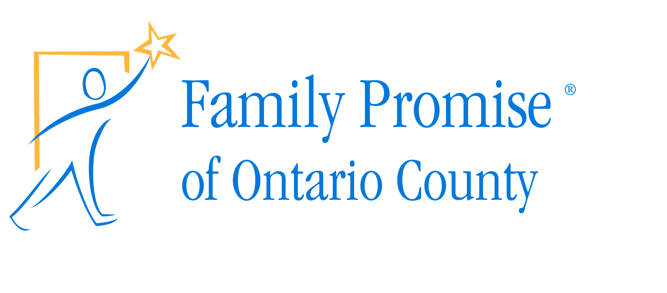
PO Box 34
Victor, NY 14564
Phone: 585-704-9776
www.FamilyPromiseOntarioCounty.org
fpocny@gmail.com

Bed Race 2018
Sponsorship Commitment

_____ Family Cornerstone ($10,000 +)
_____ Family Circle ($5,000 - $9,999)
_____ Family Advocate ($2,500 - $4,999)
_____ Family Ally ($1,000 - $2,499)
_____ Family Friend ($500 - $999)
_____ Good Neighbor ($150 - $499)

Name: _____________________________________ Title: _________________________

Company: __________________________________ Phone: ________________________

Address: __________________________________________________________________

Email: ____________________________________________________________________

Please send this commitment form and a check or money order, made out to Family Promise of Ontario County, to:

Family Promise of Ontario County
Bed Race 2018
PO Box 34
Victor, NY 14564

A representative from Family Promise of Ontario County (FPOC) will contact you via email regarding a digital logo for the T-shirt and website.

Family Promise of Ontario County is a 501(c)3 not-for-profit organization.
Building community, strengthening lives.

